**Specification Requirement Document**

Online Test Application

Developed By: Surekha Jagtap

**GitHub link:** [jagtap747/project-repository at master (github.com)](https://github.com/jagtap747/project-repository/tree/master)

Introduction

**1. P u r p o se:**

This document is meant to delineate the features of Online Test Application so as to serve as a guide to the prospective client. The Quiz application is intended to provide complete solutions for exam system through a single get way using the internet.

This Quiz Application provide features such as paging i.e. one question on each page we can navigate easily previous or next questions, Timer sets ten minutes for every Quiz after times get over its automatically gets submitted, each question carries one mark and no negative marking.

We are also able Review Quiz so that we can check on which question not answered.

1. **S c o pe:**

The Online Test Application system creates an application that enables users to provide online tests, review them, and display the results.

1. **Overall Description:**

This Online test Application contains three main modules: Quiz, Review, and Result. The quiz section of the online test application accepts the questions in JSON format. The JSON file can be easily shared from the server in the pre-defined format. The application renders the test at the client-side.

The “Review and display result” section allows users to declare the results immediately. You can simply call another JSON with the answers in it and evaluate and display the results immediately.

**Mock up**

1. **Select Quiz from drop down and click on Start Quiz button**

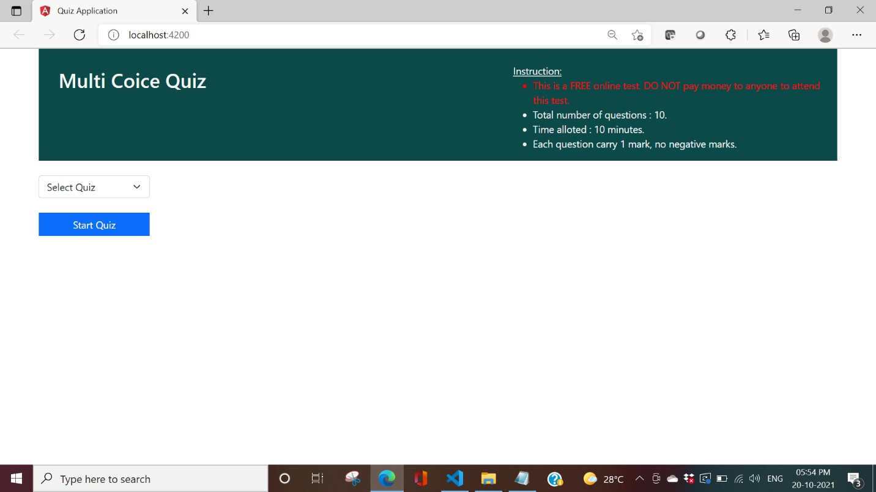

1. **Quiz Started with 10 minutes timer for 10 Questions**

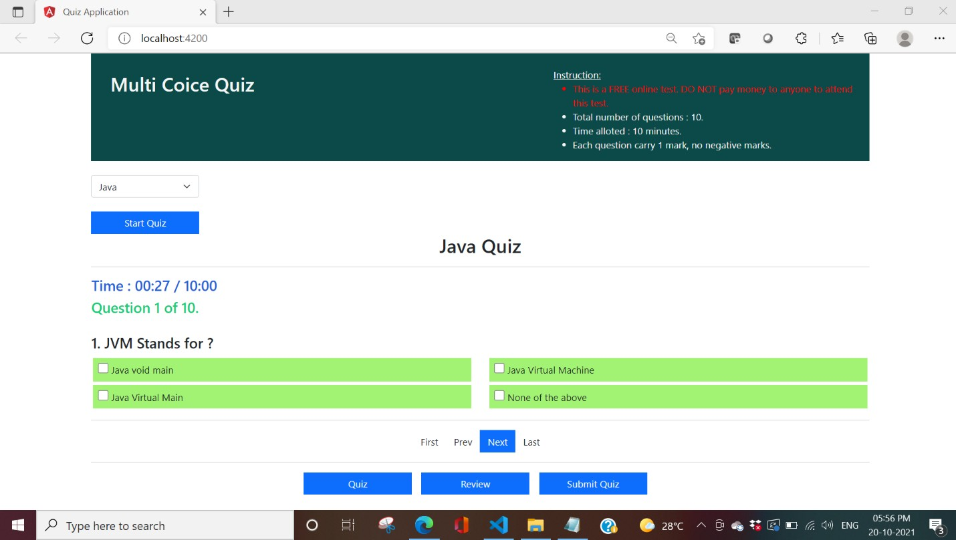

1. **Review: We can review questions to know status of un answered questions.**

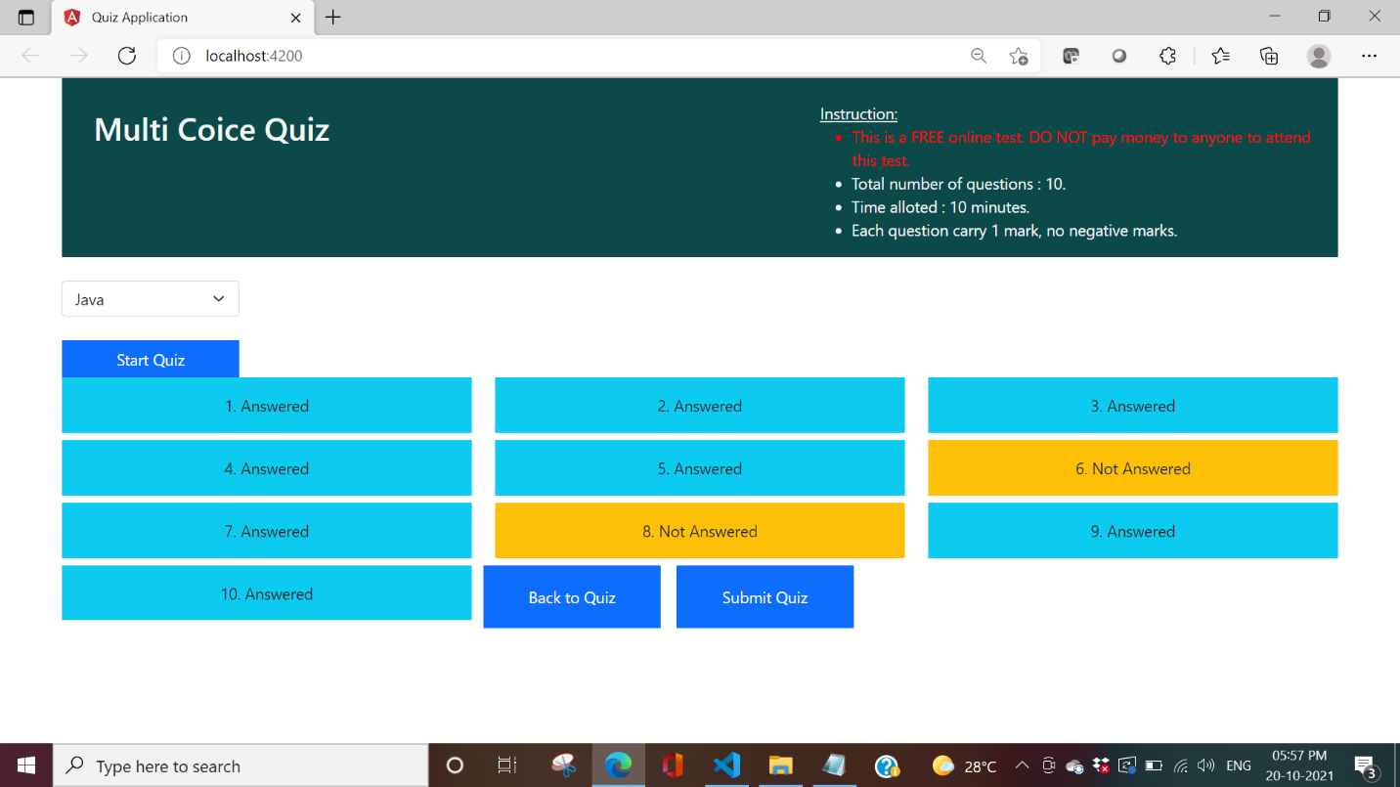

1. **We can go back to quiz for unanswered questions by clicking Back to Quiz**

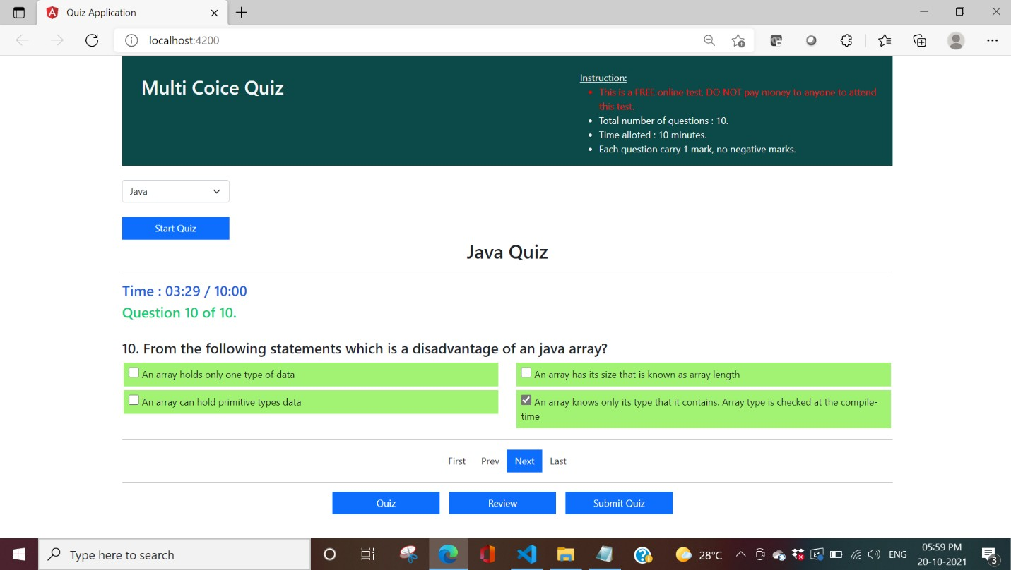

1. **Submit Quiz: Result gets Displayed**

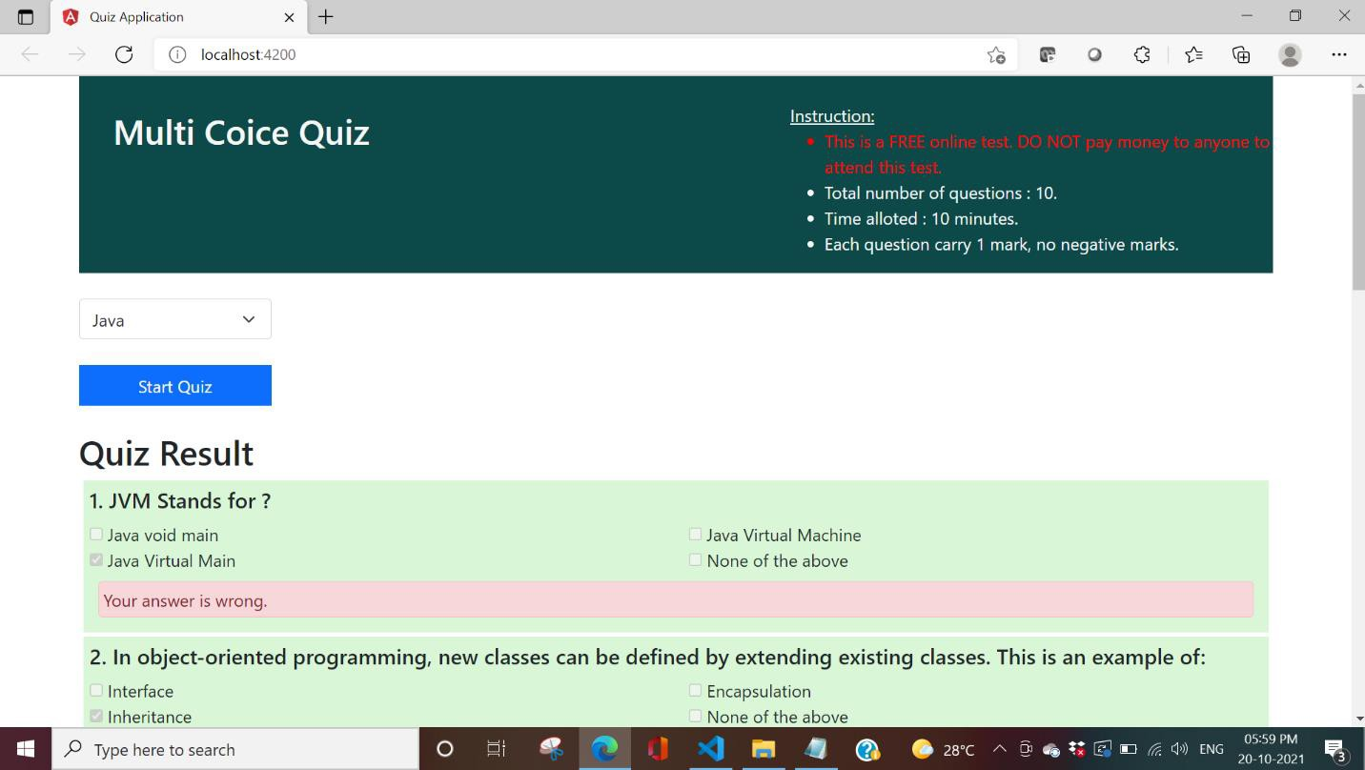

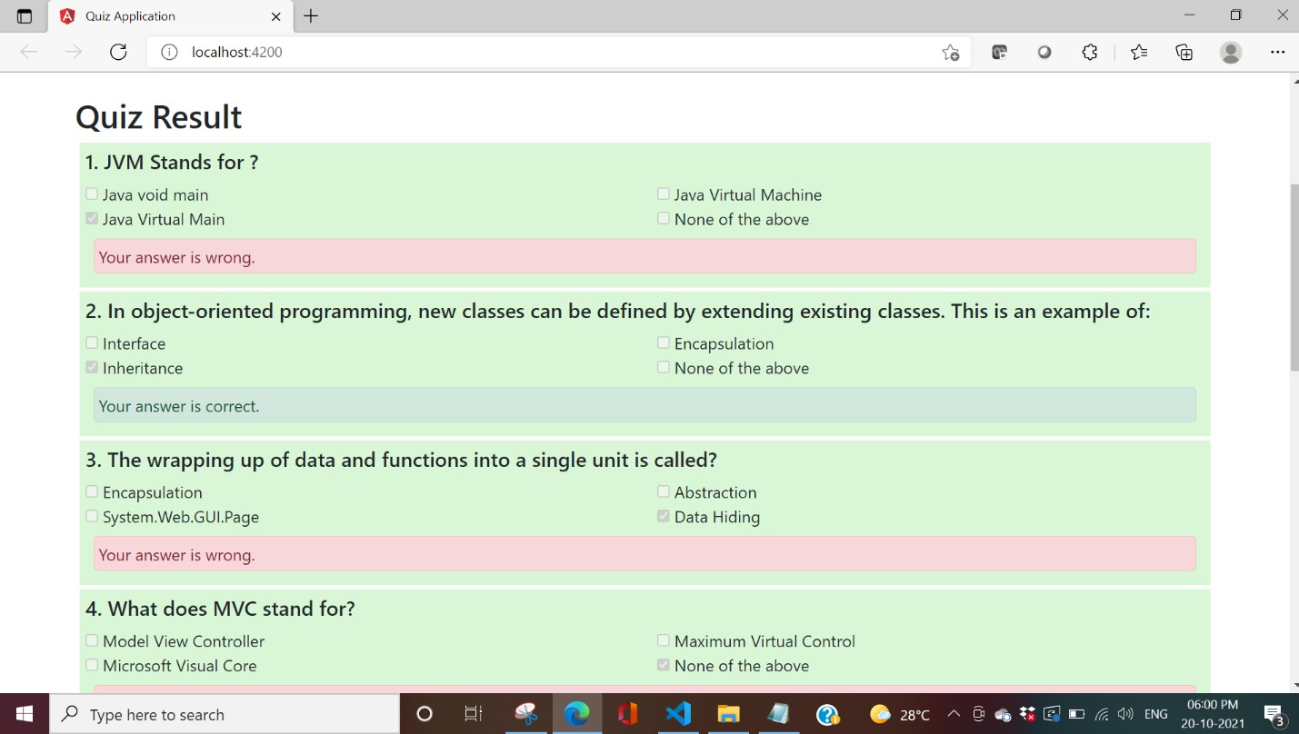

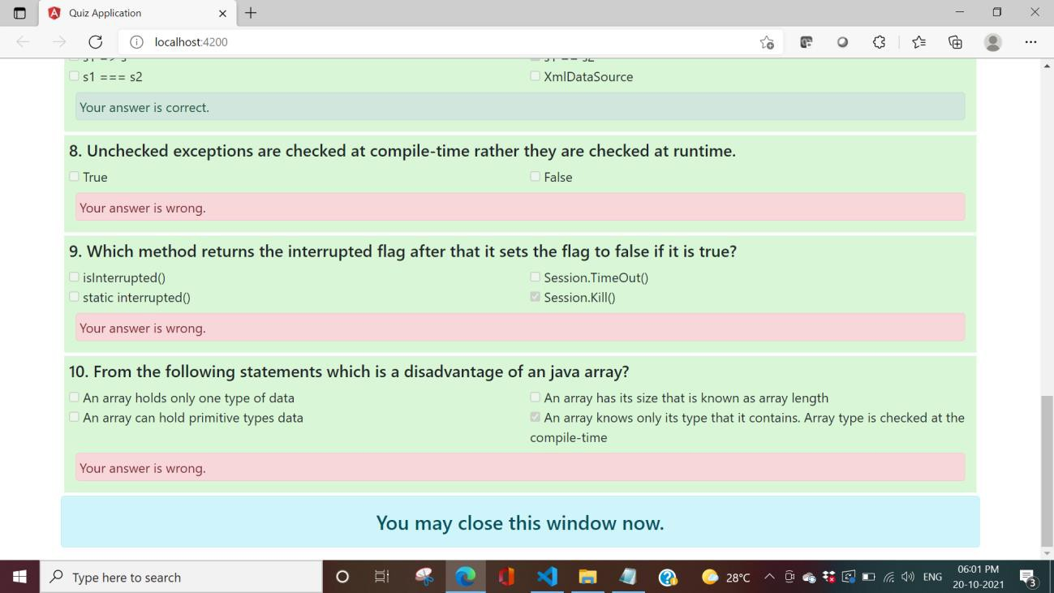

**End.**